Deeping United FC – Medical Emergency Action Plan – Training Venue

Club Name | Deeping United Football Club
Club Address | Staniland Way, Werrington, Peterborough
Postcode | PE4 6NA
Welfare Officer | Amanda Sylvester - 07976 557041

Item | Location
Defibrillator | - AED is in the reception of the leisure centre  - Another AED is located at in Werrington at 1 Amberley Slope, Peterborough, PE4 6QG
Stretcher | A stretcher is not available
1st Aid Room | A first aid room is not available
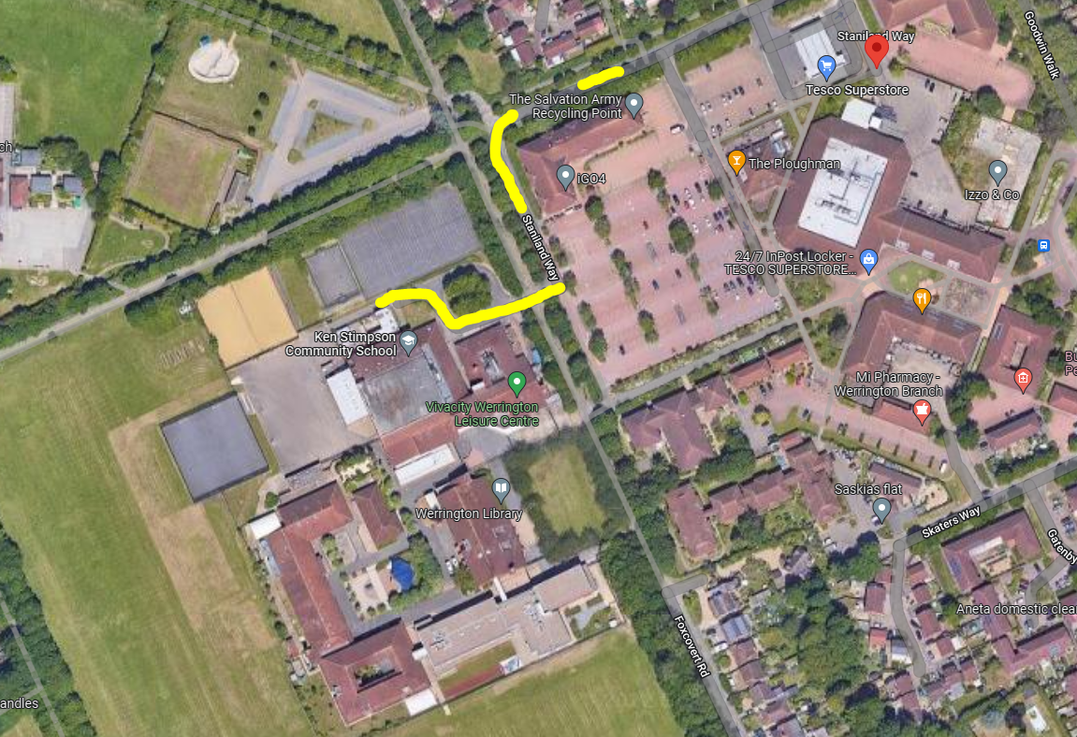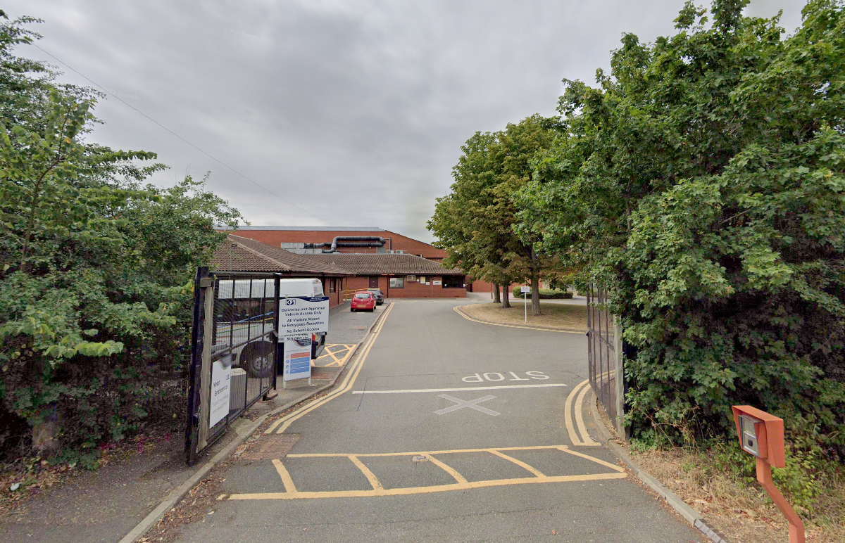

Access Routes
1, For Ambulance – Follow Postcode directions which are Staniland Way, Werrington, Peterborough PE4 6JT and enter via access gates on Staniland Way (What3words ///rate.risks.proof). Access to the pitches is available via the gates. Keys present with leisure centre staff. Go to reception and ask them to open the gates if they are locked. Go and ask in person or call 01733 864679 or 01733 864656.

2, First Aid Room to Ambulance – No room available however there is spaces in the leisure centre that would be available until ambulance arrives

3, Artificial pitches to Ambulance – Through delivery gates next to the tennis court or through the leisure centre.

4, Air ambulance – Can land in playground or on the field. Coordinates are 52.62057801986124, -0.2764669002509039. What3words is ///ripe.impact.under

Nearest Hospital:

Nearest Hospital A&E inc Contact Number | Peterborough City Hospital, Edith Cavell Campus, Bretton Gate, Peterborough  PE3 9GZ – 01733 678 000

Directions to Hospital | Follow A15 to Bretton Gate in Peterborough. Take exit 16 from Soke Pkwy/A47
Journey Time | 12 mins approx. 5.8 miles
Nearest Walk In Centre Address | City Care Centre, Thorpe Rd, Peterborough PE3 6DB – 01733 847 000

